Discussion of Confusing Statements Regarding the Origins of Bob Wirrilimarra Tucker
By Dr William B Day
2011
In 1980 Kingsley Palmer interviewed Percy Tucker who he described as a Banyjima man whose mother was a Banyjima woman with spiritual associations with a rockhole some distance east from Packsaddle (Brown 1983:6). Further detail is given by O’Connor (1996:26), who describes Percy’s mother as ‘Dandina, a Panjima-Inawongga woman from Minthay Spring, [who] married a Mr [Jacob] Tucker, a Pandjima man from the same camp.’ Minthi Spring is on the banks of the upper Turee River (see Day 2010) and although the spring is more that ‘a rockhole’, it could be the water source referred to by Palmer (1980) associated with Jacob Tucker’s ‘Panjima-Inawongga’ wife.

Brown (1983) quotes Palmer (1980:21) who recorded that Percy Tucker was born on Marillana Station and grew up on Mulga Downs. He worked as a Government dogger over a wide area of the Hamersley Ranges. According to Palmer, Percy Tucker’s father was Banyjima man who had spiritual association with a hill north of Packsaddle called Wiriwirbi. Both his father's mother and father's father were Banyjima from the Dales Gorge area.

Palmer (1980:21) continues:

Percy's [mother] was Bandjima, born on Juna Downs while his [mother's father] was Inawunga and his [mother's mother] a Bandjima probably from upper Turee. His [father] was a Bandjima who came from the Packsaddle area, and both his [father's mother] and [father's father] were Bandjima from the Dales Gorge area.

As stated above, O’Connor (1996:26) describes Percy’s mother as ‘Dandina, a Panjima-Inawongga woman from Minthay Spring, [who] married a Mr [Jacob] Tucker, a Pandjima man from the same camp. From that union are descended the Bobby, Smith (part), Smythe, Mackay, Hicks (part) and Sampi families.’ A genealogy prepared by Bill Day records Percy’s mother as Sally Djandina ‘who used to talk to Gladys [Tucker] in Innawonga language’ (pers. comm. Gladys Tucker)

Percy Tucker’s father was Jacob Tucker. Jacob’s father was Bob Wirrilimarra Tucker (Percy’s father’s father). According to Palmer’s description, Jacob Tucker ‘came from the Packsaddle area’, Percy’s mother, Sally, was ‘a Bandjima born on Juna Downs and [Sally Djandina’s] father was Inawunga and her mother was Bandjima probably from upper Turee’ (Palmer 1980). In addition, according to Palmer in 1980, Percy’s father’s father, Wirrilimarra, and his wife were from ‘the Dales Gorge area’ and his father [Jacob] ‘had spiritual association with a hill north of Packsaddle called Wiriwirbi’.

Conflicting evidence
At a conference of experts held at the Federal Court in Perth on March 11th, Kingsley Palmer suggested that he ‘may have got it back to front’ regarding the contradictory evidence that Bob Wirrilimarra Tucker and his wife ‘came from the Dales Gorge area. However, the combined documented evidence cited in this report suggests that Jacob Tucker had an affiliation with Minthi Spring, although this may have been through his marriage to a woman from that area and her Banyjima/Innawonga parents. Future generations would most likely inherit some of those rights and interests. For example, the managerial interests held by the child of a female land-owner are discussed by Peterson (1983:137), whereby ‘the managerial interest gives a nephew the right and obligation to look after the ritual property of the MB...’

In the patrilineal line, according to Palmer in 1980, Percy Tucker’s ancestors are said to have a connection to ‘a hill north of Packsaddle called Wiriwirbi’. Elsewhere, Palmer (2009:218) records Wirbiwirbi as being another name for ‘Mount Robinson’; however, Mount Robinson is almost 20 kilometres south of Packsaddle (see map below).

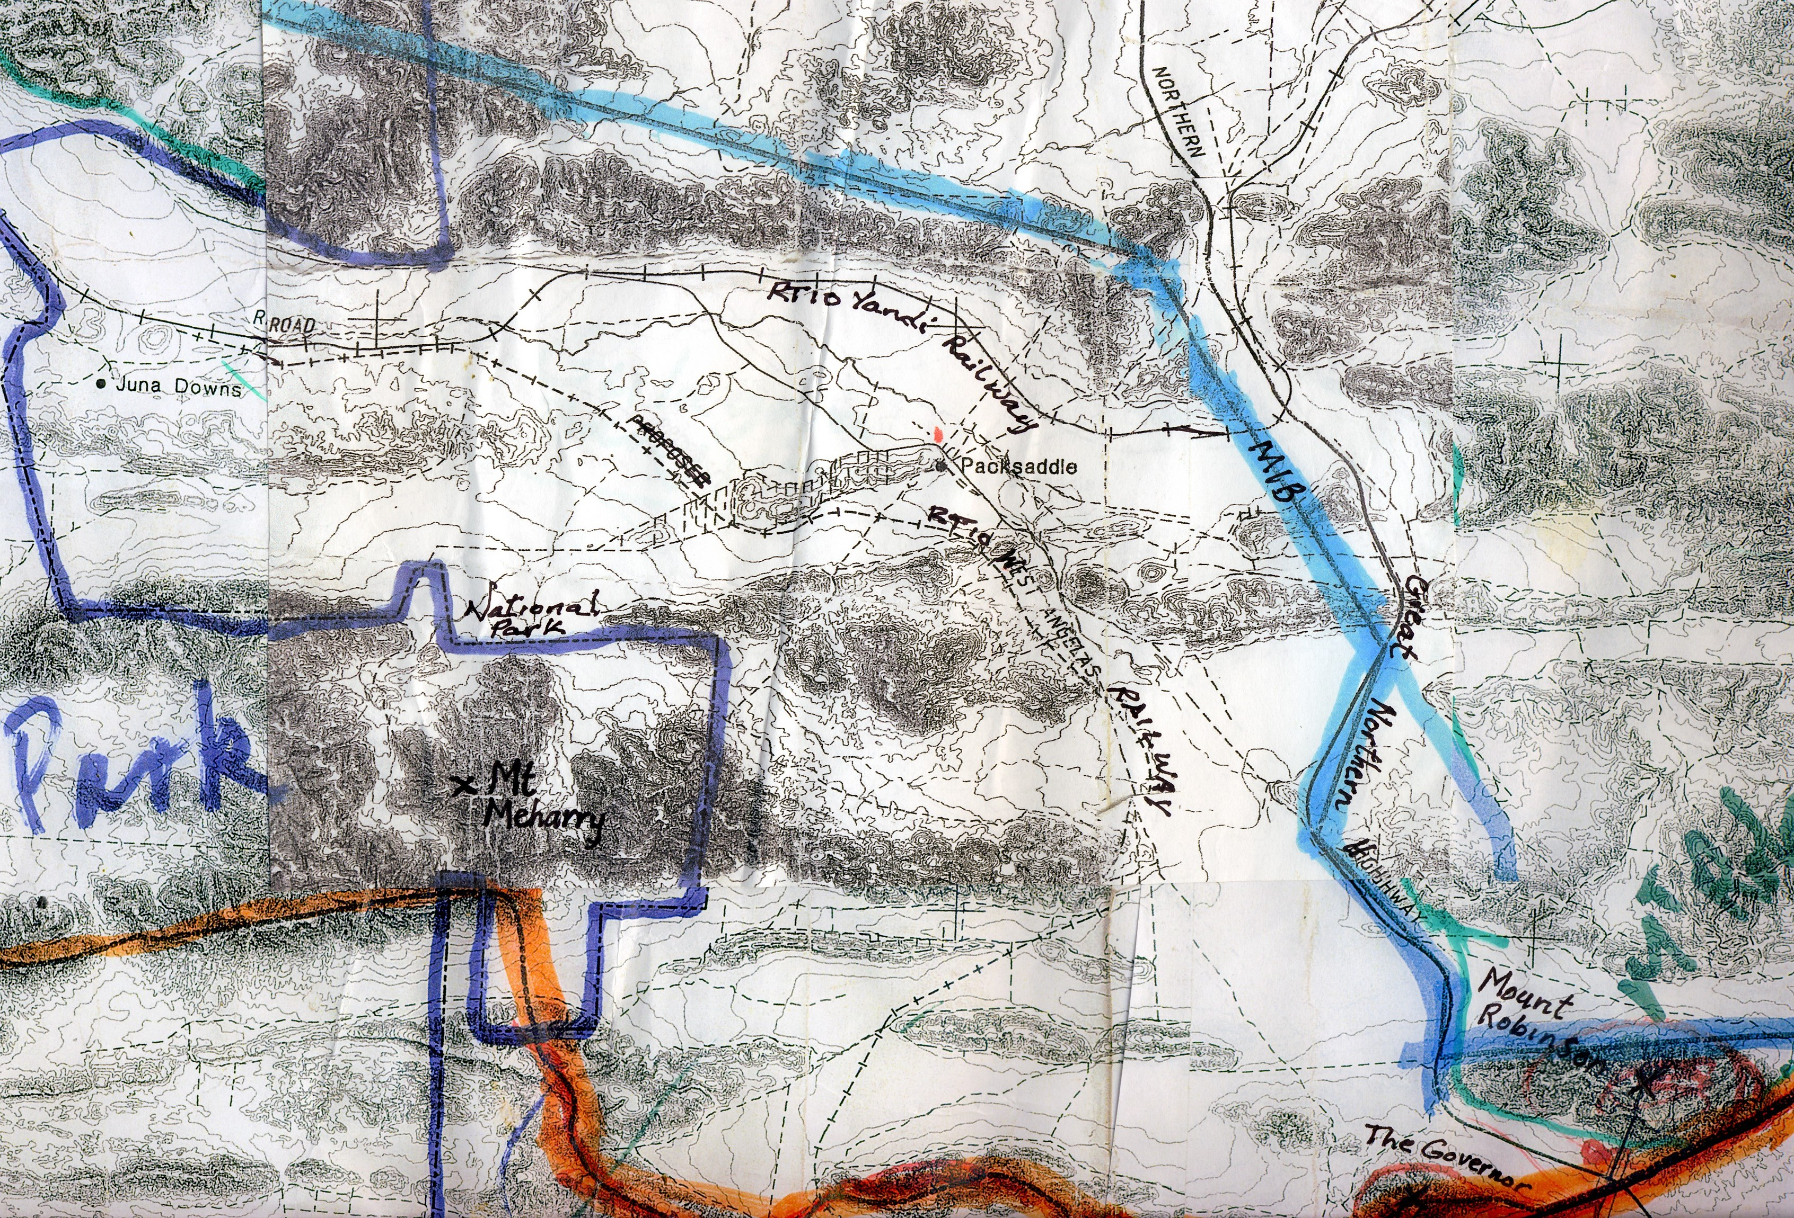
Above: Map of Packsaddle area showing Mount Meharry, Mount Robinson, The Governor, Juna Downs homestead, the boundary of the MIB native title claim, IB southern boundary, RTIO railways, Great Northern Highway and boundary of Karijini National Park.
In 1997, Wobby Parker described ‘Wirlbiwirlbi’ as being Mount Meharry, which is in a range of hills south of Packsaddle. Wobby told Noel Olive:

Mount Bruce’s Aboriginal name is Bunurrunna. Mount Meharry is Wirlbiwirlbi, that’s on the south side of Rhodes Ridge. The Kungkanhawarra Hill belongs to Lena Long’s father of Roebourne, his name was Kungkuna, my uncle. It’s just out from Newman, and from Juna Downs Station (Olive 1997:50).

To further confuse the issue, at a conference of experts held in the Federal Court building in Perth on 11th March 2011, Kingsley Palmer described ‘Wiriwirbi’ alias ‘Wirbiwirbi’ as Mount Robinson, on the southern boundary of the MIB native title claim. In his report for a single Banyjima native title claim, Palmer (2009:218) states:

In 1979 I recorded from Percy Tucker that his father Jacob was associated with the Packsaddle area and in particular with Wirbiwirbi (Mt Robinson, site 48) [my emphasis]. Jacob is buried at Mulga Downs and I was shown the location of his grave. I am of the view that Jacob is also, generally, associated with the Mulga Downs area, perhaps by virtue of his residence there, ritual status.

In Paragraph 729, Palmer (2009:219) adds:

Based on these data it is my view that Jacob Tucker probably originated from the Juna Downs-Packsaddle region. I speculate that he moved down to the station country with his parents (Bob Tucker and Thalana) as a younger man. It is possible that Tommy Tucker was born after this move to the north, thus his birth at Mulga Downs Station. The family then consolidated on Mulga Downs, acquiring an association with that place as well as the senior men gaining ritual status there.

In apparent contradiction to the above statements, Palmer (2010: Para 461) cites information provided by ‘senior claimant Alec Tucker’ who told Palmer that his ‘FF was born at Mulga Downs’. In a section headed, ‘Descent’, Palmer states:
For example, senior claimant Alec Tucker told me that Bandaguru (Fortescue River) Banjima country was his country and that of his forebears. His FF was born at Mulga Downs while his FFF (Bob Tucker or Wirilimura) may have been born near Juna Downs Station.’

As noted elsewhere, Alec Tucker’s father was Raymond Tucker, whose father (Alec’s FF) was Jacob Tucker, while in Paragraph 729 cited above, Palmer (2009) comments that ‘Jacob Tucker probably originated from the Juna Downs-Packsaddle region’.

According to records, Tommy was born in about 1882 and his sister Lucy Tucker, or Putha, about 1896. The brother of Putha and Tommy was Jacob Tucker, whose daughter Naidjong who was likely born in about 1910, with Jacob’s son Percy born in 1924. All of Jacob’s remaining four children are identified with Mulga Downs. If Jacob’s daughter was born at Mulga Downs in 1910, Jacob may have been born about 1890, after Tommy Tucker’s birth on Mulga Downs in about 1882, this is a very long association with Mulga Downs, from at least 1882 onwards, and is difficult to fit with Palmer’s suggested migration of Wirrilimarra from Juna Downs. It is suggested that more research is needed on this question.

The Tuckers at Mulga Downs
In June 1947, Tommy Tucker gave a statement to police that said in part: ‘I am a station native born at Mulga Downs Station via Roebourne. I belong to the Punjamah tribe, and I am the leader of my people.’ It appears that Tommy Tucker had a connection to Juna Downs Station. Apparently he worked there, although generally he seems to have led a migratory life. He claims that ‘When I was only young Mr William Pead of Cossack and Roebourne brought me up,’ and a Roebourne Gaol Warrant of Commitment dated December 7, 1905, states: ‘Peteronbung alias Tommy Tucker of Yandeyarra was this day duly convicted before JP...’.

In 1944 the Tucker and Parker families on Mulga Downs were linked in various ways. Some of these connections were recorded in a sworn statement to police by Wobby [Parker] after an altercation on Mulga Downs. On February 18th, 1944, Wobby stated:

Two Thursday nights ago, three sisters, Blanche, Gertie, and Selina were fighting over cards in Mulga Downs station camp. Blanche and Gertie were fighting Selina. I took the part of Selina, together with my brother Herbert, who is Selina’s man.
Darkie took the part of his two nieces, Blanche and Gertie, and Herbert and Darkie had a fight, but Darkie’s sister Ivy, joined in with another boy, so we all stopped them.

The statement then describes how Wobby tried to stop a fight between Darkie’s two sisters, Elsie and Ivy. A ‘kylie fight’ using boomerangs and shields then broke out between Wobby and Darkie. After the initial exchange of boomerangs, Darkie was struck on the head. Wobby continued, ‘As soon as Darkie fell down, my brother Herbert, speared me in the leg to stop me.’ Wobby then adds, ‘Tommy Tucker of Juno Downs Station [sic; my emphasis] was at the fight, and he took Darkie’s part, and hit me on the head with a wanna (big woman’s stick).’

Absent from the above dispute or not mentioned in the police statement, were Darkie’s brothers Raymond and Percy. Jacob Tucker’s daughter Naidjong (sister of Darkie) died before these events. According to Kim Barber’s genealogies (Barber 1997), Naidjong married Kayuna who was the brother of Whitehead, mother of Horace, Ginger, Wobby and Herbert.

Horace Parker and ‘Wirrpi-wirrpi’
In an ethnographic survey report for Mining Area C undertaken for BHP Iron Ore in 2000, Louis Warren (2000:41-42) provides additional information about a site described by Warren as ‘Wirrpi-wirrpi’ [my emphasis]. Warren states:

Of those consulted, Mr Horace Parker appeared to be clearly the most knowledgeable of the survey area. When he was present during surveys, all participants deferred to him regarding cultural heritage matters. This was likely to be partly out of respect for his seniority, in both age and position in the community...

Only one previously unrecorded ethnographic sites [sic] was recorded as a result of the survey. This site (an increase site for honey bees named Jirrplapar Thalu, MACC-FS22) was reported by Mr Horace Parker (dec), who also provided details on the previously recorded ethnographic site P02239.

The survey resulted in no other reporting of the ethnographic sites or places of cultural significance within the survey area, although Mr [Horace] Parker did reported [sic] a named location or place within the survey area. He mentioned that the general area between C deposit and Marillana Creek (with particular reference to the highest range running east/west roughly 20 km north of Mount Robinson) is named Wirrpi-wirrpi. Mr Parker referred to the range and the land in the immediate area by the name Wiirrpi-wirrpi...

Mount Meharry, identified by Olive (1997:57) as Wirlbiwirlbi, is the highest point in a range running east/west. The mount is situated about 20 kilometres west-north-west of Mount Robinson (see map). However, there is a parallel range of hills north of Packsaddle and north of the Rio Tinto Iron Ore Yandi railway line which is situated 20 kilometres north of Mount Robinson. This range of hills also form a southern boundary of a section of the MIB and better fits Warren’s description of Wirrpi-wirrpi as being ‘20 kilometres north of Mount Robinson’. The range is also north of Packsaddle, as described by Palmer (1980:21).

Warren (2000:42) adds further details about the ‘Wirrpi-wirrpi’ site. In his Area C report for BHP, Warren states:

In discussing this area with [Horace Parker] the author gained the impression that the name Wirrpi-wirrpi referred possibly to an ‘estate’ area, spoken for by a descent/estate group of that name. [Horace] also stated that ‘...the people all gone, that’s why I took it on. Quite a lot of young people around for that area but they don’t know, didn’t learn. They all come behind of me’ (H. Parker pers com).

Although other younger survey participants like Mr David Stock and Mr Horace Nelson (dec) had some knowledge of the northern part of the survey area from periods of time in the late 50s to 60s (when they worked in the areas mustering from Marillana Station) their knowledge was limited. They, along with Patrick and Henry Long, as well as Gordon Yuline, all knew various details about the previously recorded site P02239, but no others within the survey area.

Apparently, according to Louis Warren (above), Wirrpi-wirrpi is not a specific place, but rather an area, range of hills, or estate.

Summary
In summary, there is no confirmation that Wirbiwirbi is a name for Mount Robinson as claimed by Palmer (2009; see above). By 2000, according to Horace Parker, there were no surviving custodians for the area, or at least qualified people, so that Mr Parker ‘took it on’. He did not mention Percy Tucker or Percy’s father, Jacob, who was said by Palmer in 1980 to have ‘a spiritual association with a hill north of Packsaddle called Wiriwirbi’. However, the location of the estate or site Wirbiwirbi /Wirrpi was confirmed in 2000 by Horace Parker when he told Louis Warren that he was custodian of Wirbiwirbi/Wirrpi-wirrpi and that it was an area ‘20 kilometres north of Mount Robinson between Area C and Marillana Creek’. As shown on the above map, the range of hills ’20 kms north of Mount Robinson’ is a southern boundary of the Martidja Banyjima native Title Claim, while Mount Robinson itself lies on the south-west lower corner of the claim and within the IB claim.

Palmer wrote in 1980 that Percy Tucker’s F.F. and M.M. (i.e. Bob Wirrilimarra Tucker and his wife) ‘came from the Dales Gorge Area’. In 2011, Palmer claims this was a mistake. Instead Palmer suggested in 2009 that Jacob moved to Mulga Downs with his parents. Palmer (2009) states:

[Jacob] originated from the Juna Downs-Packsaddle region. I speculate that he moved down to the station country with his parents (Bob Tucker and Thalana) as a younger man.

However, Jacob’s brother, Tommy Tucker, claims to be born on Mulga Downs. Tommy’s estimated birth date is 1882 and Jacob would have to be born no later than 1890 to have a daughter (Naidjong) born at Mulga Downs before 1910. During this period Mulga Downs was a remote station often under attack from ‘hills natives’ (Day 2004).

In a statement recoded by the linguist, Alan Dench, on 19 June, 1980, Percy Tucker claims that Jacob Tucker is one of the ‘bosses’ for the Hamersley Range and that now ‘us little fellas’ are the boss, ‘We took over from the old fellas’. Percy names his father, Jacob, as ‘Pilypangkanpangu’ and lists him along with ‘Pirtanganpangu’ (Tommy Tucker) and Herbert Parker’s grandfather ‘Pirtupiri’ and father ‘Marntunah’. In his recorded statement, Percy makes no mention of other estates or spiritual connections.

Jacob married a woman from the Juna Downs area who had Innawonga-Banyjima ancestry. Jacob would have shared that connection, as would his children, by affiliation. The point is Kingsley Palmer’s information is confusing and at times contradictory. According to the evidence reviewed above, is little confirmation of Palmer’s thesis that Bob Wirrilimarra Tucker ‘originated from the Juna Downs area’, or what is the meaning of the rather loose expression, ‘originated from’. Horace Parker’s statement to Warren (2000) suggests that if Wirrilimarra’s sons had a spiritual connection to Wirbiwirbi /Wirrpi-wirrpi, it was shared by others within the MIB native title claimant group.

Mixing of groups
Through intermarriage and cognative descent, there are undeniable interconnections between groups. Warren identified five groups within the region of his survey. He lists (Warren 2000:9) ‘Martuwitja’, or Fortescue River people, ‘Milarangpa’ or ‘top-enders’, ‘Martangkara ... whose current elder is Pat Long’, ‘Inawongga’ and ‘Warrawandoo ... whose current elder is David Stock’. In discussing the mixing of groups, Warren (2000:10) continues:

1. ...Nowadays, therefore, it would be highly unusual to find a family group which is not descended from one or more such mixed marriages. This is clearly the case with the Warrawandoo group. David Stock, Horace Nelson and Horace Parker all claim descent from members of that group, yet all have mixed Pandjima and Nyiyaparli ancestry, whilst two also have a degree of non-Aboriginal ancestry. In addition, Mr [Horace] Parker is the senior elder of a neighbouring [‘Martuwitja’] group.
2. It appears from the early anthropological records that, even in the very early days of contact (and therefore, it is reasonable to assume, in the pre-contact era), the giving and taking of wives between neighbouring land-owning groups was the norm. This would tend to blur linguistic boundaries and also would create an outward-looking patchwork of rights and responsibilities in regard to parcels of land other than those normally resided upon by any given individual. The situation in the survey area also exemplifies this point.

This mixing is mostly clearly evident in exogamous marriages between Fortescue Banyjima and Indjibandi and Nyiyaparli and between Top End Banyjima and Gurama and Innawonga.
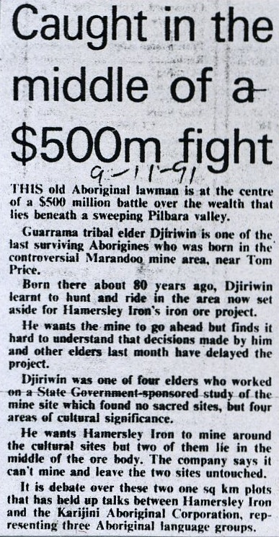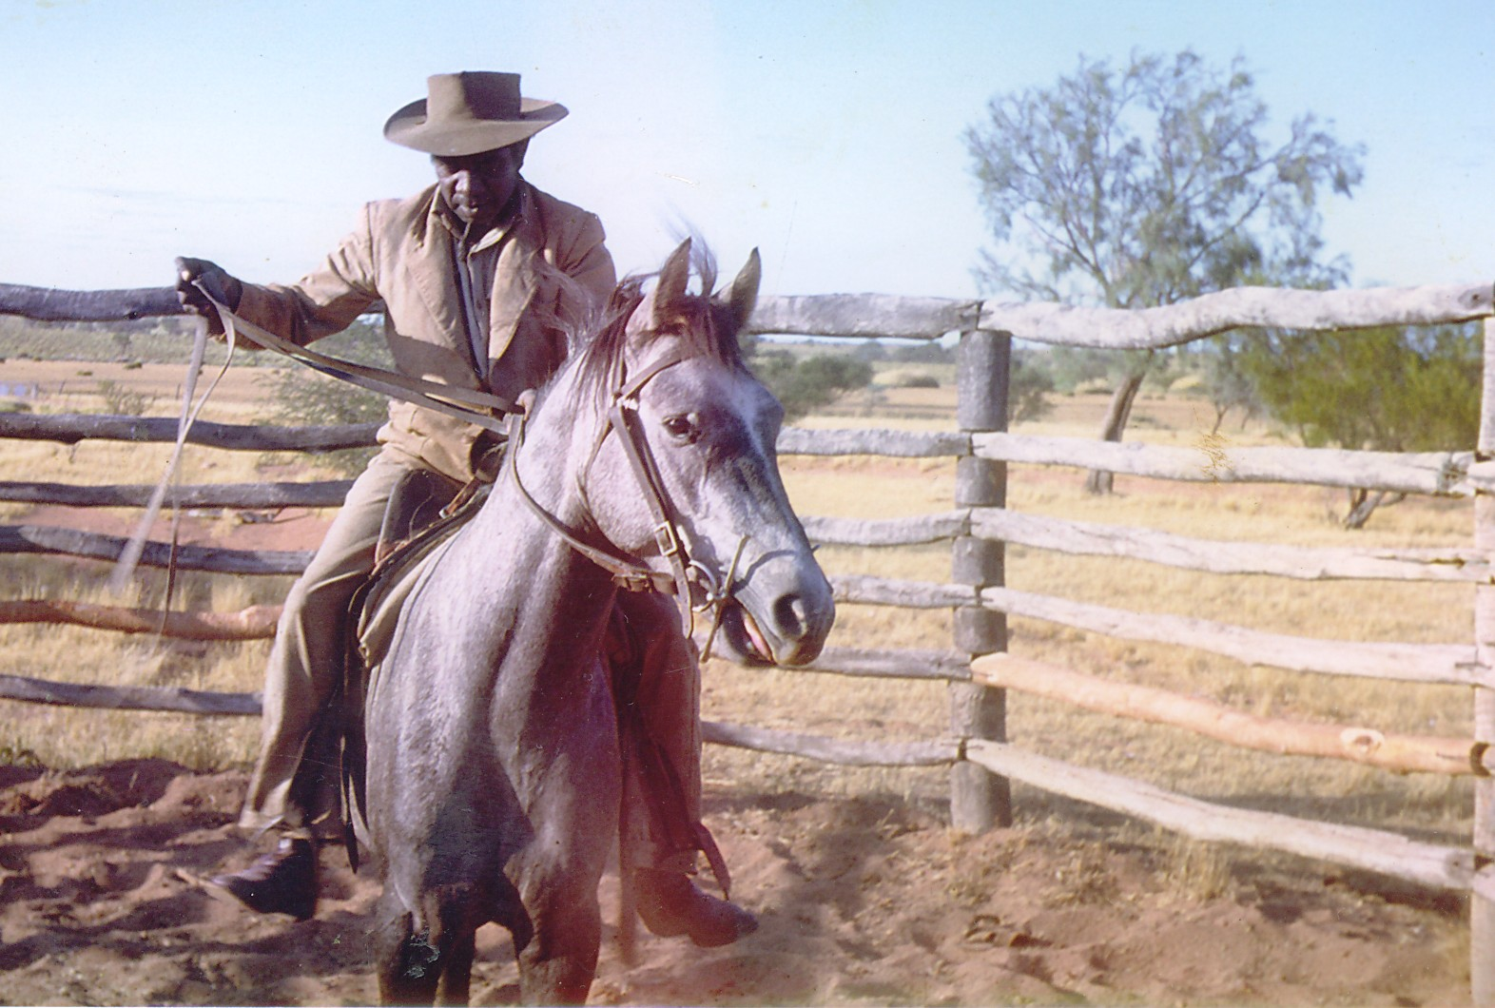
Above: Newspaper story published on November 9th, 1991, at the height of the Marandoo dispute.
Right: Percy Tucker.

Additional information on the Packsaddle-Mount Robinson Area
Bindon and Lofgren (1982:124) suggest that the concentration of walled rockshelters around the ‘Area C’ mining area near Packsaddle Ridge suggests ‘that at some stage in the prehistory of this area, large numbers of people gathered to participate in ceremonies.’ Brown and Mulvaney (1983b:6) describe the Packsaddle area as ‘a “divide” (watershed) with water courses draining north and east to the Fortescue River and south and west to the Ashburton River.’ Describing one of their informants, Brown and Mulvaney (1983b:11) cite Palmer (1979:21-22): ‘Brian Tucker is 20 years of age and of Pandjima descent. His father (now deceased) had extensive knowledge of the Hamersley Ranges and his immediate ancestors belonged to the central Hamersley Plateau.’

When the new Perth to Darwin highway was planned in 1977, staff from the Department of Aboriginal Sites examined the Packsaddle to Munjina Gorge section (Brown 1983). Kingsley Palmer also investigated Aboriginal sites in the area between 1975 and 1980 (Palmer 1975, 1976, 1979, 1980). Concerning the Packsaddle area, Brown (1983:9) wrote:

Generally the Pandjima have taken responsibility to ‘speak for the country’. Specifically Herbert Parker and his two brothers appear to be the ‘caretakers’ and spokesmen for this [Packsaddle] area. However, Jerry Wing, who is recognised as being the most authoritative person for an area west of the survey area, seems to have the most knowledge of the southern Packsaddle area.

Kingsley Palmer (1980:15) described Jerry Wing in almost the same terms. In a paragraph following the genealogical background of Percy Tucker, Palmer wrote:

However, it is Jerry Wing who is considered by Aborigines now living in Onslow and Roebourne as being the most authoritative person with spiritual affiliations to the central Hamersley region. Last year (November) I took Jerry through the Hamersley ranges while undertaking anthropological research concerning other Temporary Reserves in the region ... I also undertook quite extensive enquiries concerning the Marandoo area in 1975 (see Palmer 1975:4-6).

Djirriwiyn alias Gerry Wednesday alias Jerry Wing (dec) was a Gurama/Top End Banyjima man who is recorded by DIA as the custodiam of Minthi Spring (Mindayi DIA Site 8296). In 1980, Kingsley Palmer noted:

Jerry Wing is approximately 70 years old and lives on Peedamulla station. His M.M.. and M.F were both Banyjima from Weeli Wolli and Mindi Springs respectively and his second M.F. and his mother were Banyjima from Hamersley Station. His F.F. was from lower Turee Creek (Inawunga), his M.F. was Gurama from Rocklea and his father was Gurama from an area west of Paraburdoo. Jerry's F.F. is believed to live as a spirit inside Bimbulungu 6 kms north west of Mt Bruce.

Brown (1983:9) notes: ‘[Jerry] was not generally familiar with a lot of the area north of Packsaddle. He specifically mentioned the snake track and stone arrangement site which he had described to Kingsley Palmer.’ A continuation of the track left by the snake was pointed out to the anthropologist John Wilson who documented Aboriginal sites in the Angelo River area in 1979-80 (Wilson 1980:14-15).

In 1979, Jerry Wing described to Palmer (1979:19) a snake track and stone arrangement site (see also Brown and Mulvaney 1983a:46):

On the low range, east of the lake (Gundawuna), are located a dozen or more rocks each about the size of a human head. In the Dreaming a snake travelled from a spring in a big hill north of the lake, and went south, where it dropped its eggs at this site. These eggs turned into stones. The snake travelled on, and made the gap between The Governor and Mount Robinson. The stones are very dangerous, and he who touches them will ‘swell up’ and perhaps die. It is also dangerous to allow your shadow to fall on them.

In ‘The Giles Mini Report’, Palmer (1976:4) cites the explorer, Ernest Giles (18989), who named Mount Robinson and The Governor ‘as lasting memorials to the intelligent and generous interest displayed by Governor Robinson [of Western Australia] (Giles 1989:299)’. Palmer (1976:5) also records that the Aboriginal name for The Governor is Winda-rama. He adds, ‘Traditionally the country around Giles Mini was owned by the Mardu-idja, who had close affiliations with the Munda-ra, further west. Mardu-idja country extended eastwards to the present Mt Newman townsite and south to Round Hill (Djugadidina) and east towards Silvania [sic].’

Tindale (1974:247), cited in Warren 2000:14), described the ‘Mundara’ as:

A small tribe on the Opthalmia Range and on the plateau at the head of Turee and Weediwolli Creeks; south to Prairie Downs. Driven north to the Fortescue River by a southeastward movement of the Panjima and absorbed among the Niabali and Pandjima. Now extinct as a tribe.

More recently Edward McDonald goes to some length to explain the absence of any surviving evidence of the ‘Mundara tribe’ as a separate group. McDonald (2000:8) notes that ‘Mandara is not a tribal name that is generally recognised today by Aboriginal consultants participating in various surveys in the region’ (see also McDonald 1999) and suggests that the ‘Mundara’ referred to by Tindale and Palmer is actually a descriptive term for a location, rather than a ‘tribe’. In his report, McDonald (2000:8-9) states:

The term is more likely to be a local rather than a ‘tribal’ name or a descriptive term for ‘hill’ or upland people. Indeed, Palmer (1977:24) states that the Mundara [Mandara] are ‘a sub-group of the Bandjima [Panyjima] people.’ The term munda/manda would seem to be derived from a word common in Hamersley Range languages for hill/rock/stone [manda/marnda/marnta] (Dench 1991:230). The suffix –ra, according to Dench, is common in various Pilbara languages as an indication of people from a particular place (pers. comm.. September 1999; Dench 1987:2...

References:
Barber, K 1997 A Report to the Gumala Aboriginal Corporation on Elements of the Native Title Interests in the Vicinity of Hamersley Iron’s Yandicoogina Project. Tom Price, WA: Unpublished report.
Bindon and Lofgren 1982
Brown S H 1983 Perth-Darwin National Highway Newman-Port Hedland Section: A Survey for Aboriginal Sites on some Proposed Route Realignments. Prepared for Main Roads Department.
Brown, S H and K Mulvaney 1983a A Survey For Aboriginal Archaeological Sites Relating To A Part Of , And Some Associated Works On, The Perth – Darwin National Highway. Prepared for the Main Roads Department
Brown, S H and K Mulvaney 1983b Test Pit Excavations at Aboriginal Sites P4627, P4623, P5315 and P5316 Perth – Darwin National Highway Newman – Port Hedland Section. Prepared for the Main Roads Department
Day, W B 2004 Murder, Trial and Execution in the Pilbara: the Death of James Coppin. Unpublished essay.
Day, W B 2010 Report on Martidja Banyjima Minthi Spring Section 18 Consultation concerning Rio Tinto Iron Ore’s Marandoo Below Water Table Mining Project: Notes on Discussions held at Karijini Eco Retreat, September 1st and 2nd, 2010. Unpublished report for Martidja Banyjima native title claimants.
Dench, A 1987 Maruthunia: An Aboriginal Language of the Pilbara Region of Western Australia. PhD Thesis, Australian National University, Canberra.
Dench, A 1991 ‘Panyjima’. In R M W Dixon and B J Blake, eds. The Handbook of Australian Languages, Volume 4. Pp. 125-141. Oxford: Oxford University Press.
Giles, E 1889 (1995 reprint) Australia Twice Traversed. Victoria Park, WA: Hesperian Press. 382pp.
McDonald, E M 1999 Report of an Ethnographic Aboriginal Heritage Survey of the Exploration Areas in the Vicinity of Ophthalmia, Pilbara, Western Australia. Unpublished Report Prepared for Hamersley Iron and the Nyiyaparli Claimants.
McDonald, E M 2000 Report on an Ethnographic Survey for Aboriginal Sites of the Exploration Areas in the Rhodes Ridge, Pilbara, Western Australia. Prepared for Hamersley Iron and the Nyiyaparli Aboriginal Corporation and the Gumala Aboriginal Corporation.
O'Connor, R 1991 Report on Aboriginal Person-Land Relationships Central Pilbara Region. For Hamersley Iron Pty Ltd.
Olive, Noel 1997 Karijini Mirlilirli: Aboriginal histories from the Pilbara. Fremantle: Fremantle Arts Centre Press.
Palmer, K. 1975. The Marandoo Report. Unpublished report for Department of Aboriginal Sites, WA Museum.
Palmer, K 1977 ‘Stone arrangements and Mythology’, Mankind 11 (1): 33-38.
Palmer, K 1976 The Giles Mini Report. Unpublished report for Aboriginal Sites Department, Western Australian Museum, Perth.
Palmer, K. 1979. An Archaeological Survey of the Proposed Railway Line Route: West Angelas Project. Part 2 (53.9km Peg - 306km Peg). Unpublished report held by AAD.
Palmer, K 1980 The Central Hamersley Plateau, An anthropological Survey: an account of known sites and places of importance to Aborigines in the vicinity of TR 4885, TR 5623, TR 5585, TR 6998 and TR 6999. A Report Prepared for Texasgulf Australia.
Palmer, Kingsley 2009 Innawonga And Bunjima People Native Title Application WC96/61; WAD6096/98, Martu Idja Banyjima People Native Title Application WC98/62; WAD 6278/98: Anthropologist’s Report. Mongarlowe, NSW: Appleby Consulting Pty Ltd
Peterson, N 1983 Rights, residence and process in Australian territorial organisation. In Aborigines, land and land rights. N Peterson and M Langton, eds. Pp.134-145. Canberra: Australian Institute of Aboriginal Studies.
Tindale, N B 1974 Aboriginal Tribes of Australia: the terrain, environmental controls, distribution, limits and proper names. Berkeley: University of California Press.
Wilson, J 1980

Palmer 1979b, 21.
Alec Tucker and others KPFN, 52.
Alec Tucker KPFN, 12. This may have led Marnmu Smyth to suggest to me that Jacob was ‘more for Mulga Downs’; KPFN, 14.
Alec Tucker KPFN, 12 (Palmer 2010:133).
Mark Chambers records that Tommy Tucker was 73 when he died on December 10, 1955.
Department of Native Welfare, Report on Applicant for Certificate of Citizenship, Jack Dowton. According to this form, Putha’s son, also listed as Jack, was born in 1906.
DIA File 470/1936: 17-11-1936 ‘At White Springs stations recently I came across a native woman (full blood) named Naidong - no English alias - who had two very light half caste boys with her - Harold aged 5 years and Eric aged 4 years. She stated that she was a kitchen gin at Mulga Downs station and that she was at White Springs for a holiday.'
Naidjong, Elsie, Ivy, Raymond, Doug, Percy.
PDD File 2300/47. June 1947. George Park of Juna Downs complained that Blanche [Tucker] was being held by Tommy after being speared in the leg to prevent her running away. Investigating a complaint by George Park of Juna Downs station regarding the 'alleged spearing of a Gin by native known as Tommy Tucker,' the police constable wrote: Tommy Tucker claims that he is head of his tribe; and for a station native he is well educated. He is known as a native lawyer. His native name is 'Bedernungbung' and he states that when only a young man he served three months in the Roebourne Gaol but claims he does not know for what offence It appears apparent that when Tommy regained possession of Blanche at the gathering of the natives at Mulga Downs Station during March 1947 after she had been residing with Toby for several months; he remained at Mulga Downs until their baby died and then commenced his return journey to Juna Downs.
see PDD File 2300/47
Blanche Tucker, born 1923, granddaughter of Jacob, is the mother of Lindsay, Archie and Gregory.
Gertie Tucker, alias Garditha, born 1916, granddaughter of Jacob, married Ginger Parker, born about 1909, brother of Herbert. Her daughter was Sella Robinson.
In 1958 Mulga Downs station report lists Pat, stockman on 5 pounds and keep and Selina, 40 yrs wife of Pat [Long]. Selina, housegirl has diabetes and is taking insulin.
Herbert Parker, born 1921, brother of Wobby, Horace and Ginger.
Doug Tucker, son of Jacob, died in Royal Perth Hospital on 11th May, 1944. He is buried in Karrakatta grave LC0617.
Nulingu Ivy Tucker, daughter of Jacob, married a Ngarlawongga man named Spider (see Barber 1997).
Elsie, daughter of Jacob, was the cook at Mulga Downs Station. 1944 Mulga Downs Report to Commissioner Native Affairs states: There is also a half-caste child named Johnnie, aged about 4 years, the son of a deceased woman named Mahjong, [Naidjong] who is alleged to have been taken from Roy Hill to Port Hedland and died there in the Locke Hospital, the child is now being cared for by a full blood woman named Elsie, the sister of Mahjong. Telegram 5-7-1949: ELSIE FROM MULGA DOWNS DESIROUS TRAVELLING CARNARVON TO VISIT HALFCASTE SON DOUGLAS MCARTHUR AT MISSION.
Raymond Tucker, born 1913, son of Jacob, is the husband of Egypt, born 1913, mother of Alec Tucker, born 1943. Egypt is also the mother of Ronnie Mills, born 1942, son of Wobby.
See footnote 16, above.
Horace Parker died suddenly on March 31, 2000.
Statement by Percy Tucker recorded by Alan Dench, at Onslow Nhuwala Centre, 19 June, 1980. Copy faxed by Alan Dench, University of Western Australia, to Mark Chambers of Yamatji Land and Sea Council, on 28 February 2005.
Palmer (1980) describes Mindi Springs (Mindayi) as 'The place where the spiritual essence or Dreaming of Jerry Wing's M.F. was located.
Palmer reveals a complicated web. Jerry’s mother, Maggie Yalluwarra (1899-1959), had children from Gurama men, George Pintangati and Johnny. His mother’s mother Kudjipangu (TE Banyjima) was married to Gurama elder, Bindimai (1871-1931) and Idinggananha, mother of Kunyanbina ( TE Banyjima).
Brown and Mulvaney (1983a:46) note: Since the site is known to living Aboriginal people and is of traditional significance to these people as well as being of anthropological and archaeological importance the site should be made a Protected Area under Section 19 of the Aboriginal Heritage Act 1972-1980.

